Research Documentation
Contents
Research Documentation 1
Examples of Models 1
Pros of AI Digital Forensics 1
Cons/Challenges of AI Digital Forensics 1
Week 4 3
Cons/Challenges of AI Digital Forensics 3
Where its useful 3
Week 5 4

Examples of Models
-BelkaGPT/BelkaHUB https://belkasoft.com/x Paid general purpose all-in-one AI DFIR tool.
- Unfold, https://github.com/arazazi/unfold A forensics investigations suite for disk and memory forensics, optimized for CTF, works with windows and Linux, uses volatility 3. Can be applied to .dd files. Believe it uses external openai for its ai features.
- Valhuntir, https://github.com/AppliedIR/Valhuntir This free solution explicitly mentions the capacity to employ a diverse range of locally installed AI clients. Supports a traditional DFIR workflow, employs sources of evidence we are familiar with (Volatility, Suricata, eventlogs). The solution runs on a private forensic network.
- Unearth, https://github.com/bhargavgajare1479/Unearth Unique investigative platform with its own AI agent that conducts file carving, metadata extraction, automatic hashing, and creates a timeline of events based on the forensic evidence. Includes unique features that may reveal otherwise undetectable insights such as AI generated content detection, automatic false-context/false-claim detection based on existing environmental & open-source information.

Pros of AI Digital Forensics
-Narrow down vast data by topic “show me messages where financial transactions are discussed”, can find relevant information without exact language, with synonymous or slang language irrelevant.
-Interpret and translate the content of audio files
-Identify faces, specific brands of clothing, models of cars, and allows you to search and associate this information within a dataset

Cons/Challenges of AI Digital Forensics
-Cannot use public/cloud solutions, due to sending private forensics-relevant data to datacenters where its integrity and possession of evidence are compromised and no longer legally useful because of this.
- Forensics tools are constantly updated and AI models are constantly updated making it difficult to work a solution that includes both without constant maintenance and obsolescence/misconfiguration.

Week 4
"The objective of the CFTT program is to provide measurable assurance to practitioners, researchers and other applicable users that the tools used in computer forensics investigations provide accurate results." https://www.ojp.gov/pdffiles1/nij/238993.pdf
Table design for artifacts, could add columns for if each tool found?
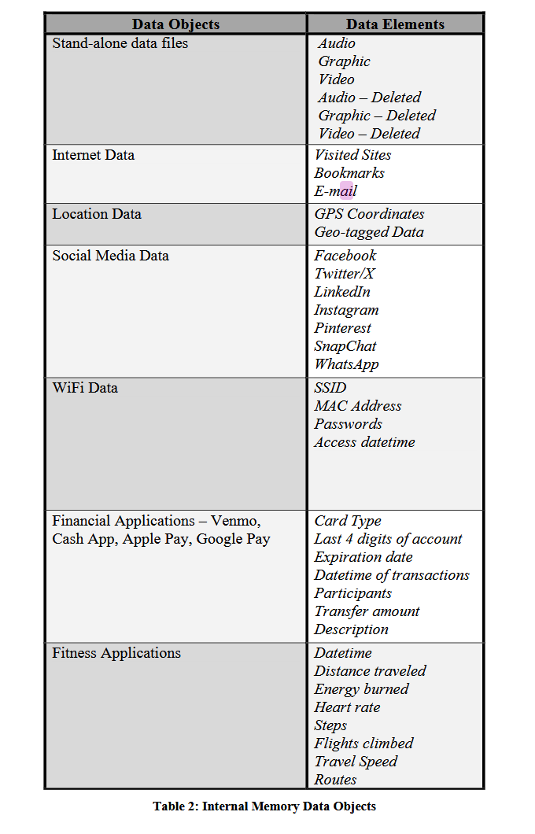

Cons/Challenges of AI Digital Forensics
Cant find/Analyse things that are not there
24 year forensic examiner thinks AI does not have a place in DF,
Don’t use AI in a situation where you cant undo something
How are we validating the output?

Where it is useful
To find a string to pull

Week 5

Keynote | DFIR AI-ze Your Workflow – Mari DeGrazia
Ollama – serves model in backend
Openwebui – graphical front end to access
Now you have complete control of client data within your environment
She just puts data directly into the message dialogue (ShimCache)
She uses it to translate Spanish chat messages in a mobile forensics dataset
Believes we can get beyond just placing something in a chat box and asking AI about it, can integrate and automate workflow processes of digital forensics through agentification

Downsides + ways to mitigate hallucinations
Trust tools but verify
AI models make lots of mistakes
“How are we supposed to use this tech in dfir if ai out of the gate is making mistakes”
Epoch timestamps totally incorrectly converted
To mitigate this weakness, give the tool access to a proper epoch timestamp converter, rather than letting it hallucinate some output, augment the tool’s weaknesses
Uses python to automate things

API Calls
Has the ai automate things on the backend
Conducts an ip address analysis, the bot gives a table with a column for the tool used to collect the information it supplies

Creating an agent
Giving the LLM multiple tools to CHOOSE from

MCP Servers
Can serve via the MCP protocol the tools she has

Velociraptor
Integrating velociraptor DFIR visibility tool so that ai can check the targeted collection of evidence across endpoints speedily

LiteLLM
Open-source proxy server, API that lets you access and serve LLM models

Table of AI/Legacy Tools
Tool | Purpose | AI/Non-AI | Works? | Link
Hashcat | Password Cracker | Non-AI | Yes | https://github.com/hashcat/hashcat
John The Ripper | Password Cracker | Non-AI | Yes | https://gchq.github.io/CyberChef/
Cyberchef | Decoder | Non-AI | Yes | https://gchq.github.io/CyberChef/
Volatility (2/3) | Memory Analysis | Non-AI | Yes | https://github.com/volatilityfoundation/volatility3
Exiftool | Metadata Analysis/Modification | Non-AI | Yes | https://exiftool.org/
Foremost | File Carving | Non-AI | Yes | https://www.kali.org/tools/foremost/
Sherloq | Picture forensics | Non-AI, has AI plugin | Yes | https://github.com/GuidoBartoli/sherloq
TruFor | Image manipulation detection | AI plugin for Sherloq | No | https://github.com/grip-unina/TruFor
Wireshark | PCAP/Network Analysis | Non-AI | Yes | https://www.wireshark.org/
PassLLM | Password Cracker | AI | Yes | https://github.com/Tzohar/PassLLM
Unearth | Data recovery | AI | No | https://github.com/bhargavgajare1479/Unearth
Valhuntir | File recovery/analysis | AI | No | https://github.com/AppliedIR/Valhuntir
Unfold | Automated memory analysis | AI | No | https://github.com/arazazi/unfold

